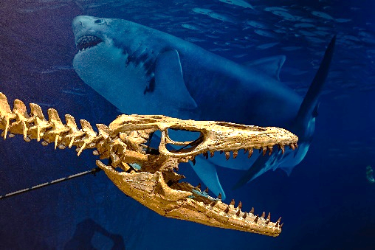

The National Museum of Natural History remains temporarily closed to support the effort to contain the spread of COVID-19.

UNTIL IT OPENS AGAIN … WANT TO LEARN MORE?

Smithsonian Virtual Tour
https://naturalhistory2.si.edu/vt3/misc/z_tour-m001.html

Smithsonian Ocean Portal
https://naturalhistory.si.edu/exhibits/sea-monsters-unearthed-life-angolas-ancient-seas
https://ocean.si.edu/through-time/if-you-build-ocean-sea-monsters-will-come
https://ocean.si.edu/through-time/ancient-seas/meals-mighty-mosasaur
https://ocean.si.edu/through-time/ancient-seas/cretaceous-benguela-current-ecosystem
https://ocean.si.edu/through-time/ancient-seas/modern-benguela-current-ecosystem

Smithsonian Magazine
https://www.smithsonianmag.com/blogs/national-museum-of-natural-history/2018/12/07/ever-wonder-how-exhibits-are-made-heres-your-answer/

African Voices Exhibit
Angolan Voices at the Smithsonian
https://www.youtube.com/watch?v=Mm_grZakY_Q&feature=youtu.be

Washington Post Science Magic Show https://www.youtube.com/watch?v=m_b1lntFADU

Voice of America
https://www.voanews.com/a/fossils-from-angola-bring-strange-yet-familiar-ocean-into-view/4662712.html

National Public Radio, Christopher Joyce, Science Reporter
https://www.npr.org/2018/11/08/659551721/scientists-unveil-ancient-sea-monsters-found-in-angola

PaleoAngola Video
https://www.youtube.com/watch?v=LfQ1PKxBR9s

PaleoAngola Blog
http://paleolabs.org/PaleoAngola2/

